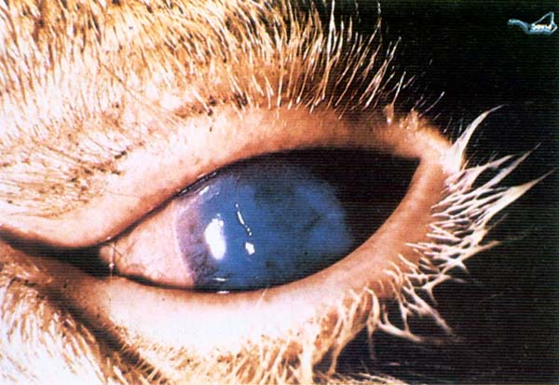

**Organ:** Tongue and Buccal mucosa

**Lesion:** multiple areas of erosion and ulceration on tongue and buccal mucosa.

**Etiology:**  genus *Macavirus* of the family Herpesviridae

**Diagnosis:** Malignant catarrhal fever (MCF)

**Organ:** Eye

**Lesion:** Early stage of corneal opacity, conjunctivitis and reddening of the eye lids.

**Etiology:**  genus *Macavirus* of the family Herpesviridae

**Diagnosis:** Malignant catarrhal fever (MCF)

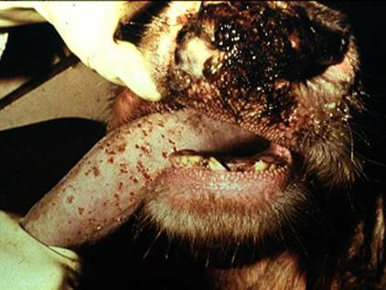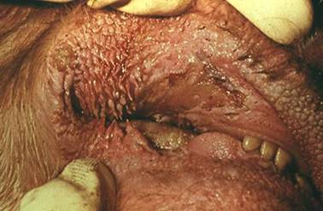

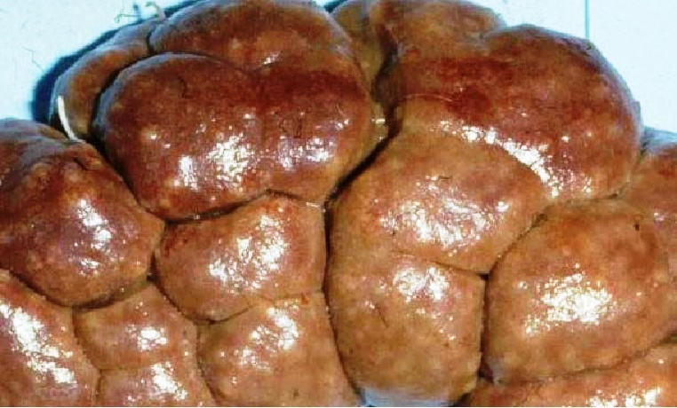

**Organ:** Kiney (Bovine)

**Lesion:** There are many areas of hemorrhage and pale focal lesions on the kidney.

**Etiology:**  genus *Macavirus* of the family Herpesviridae

**Diagnosis:** Malignant catarrhal fever (MCF)

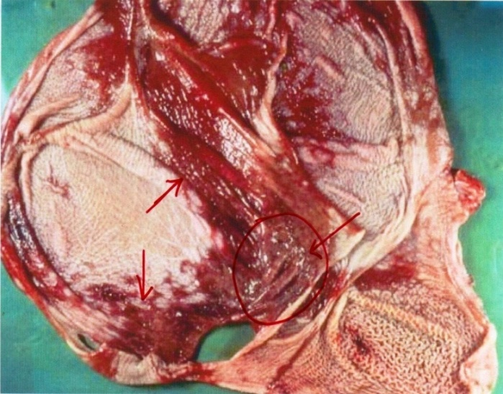

**Organ:** Reticulum and omasum

**Lesion:** Severe hemorrhagic area in the mucosal surface of omasum and reticulum also present of ulcer.

**Etiology:** genus *Macavirus* of the family Herpesviridae

**Diagnosis:** Malignant catarrhal fever (MCF)

**Organ:**  Brain

**Lesion:** congestion of blood vessel withperivascular lymphoid infiltration.

**Etiology:** genus *Macavirus* of the family Herpesviridae

**Diagnosis:** Malignant catarrhal fever (MCF)

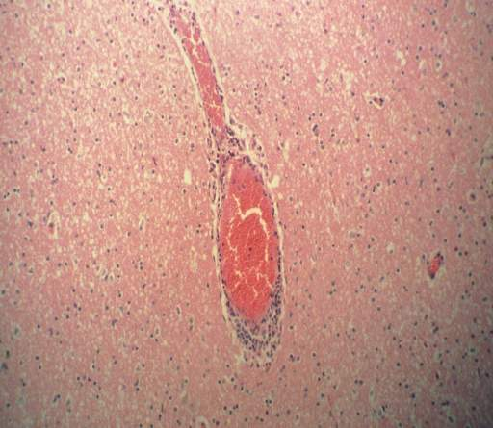

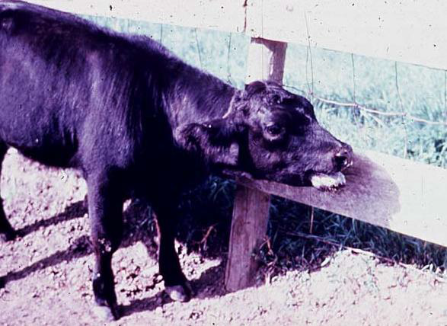

**Organ:**  Calf

**Lesion:** signs of pneumonia includes: Depression and drooping ears, an extended head, a bowel back and the calf isolated itself from other animals.

**Etiology:** *Pasteurella multocida* (or other causes of shipping fever *Mannheimia haemolytica* and less commonly *Histophilus somni)*

**Diagnosis:** Pasteurellosis (Shipping fever).

**Organ:** Lung

**Lesion:** there is extensive reddish black discoloration on lung parenchyma represented of consolidation and there is white yellowish discoloration on lung parenchyma represented of hemorrhage fibrnonecrotic pneumonia.

**Etiology:** *Pasteurella multocida* (or other causes of shipping fever *Mannheimia haemolytica* and less commonly *Histophilus somni)*

**Diagnosis:** Pasteurellosis (Shipping fever).



**Organ:** Lung

**Lesion:** there is extensive reddish black discoloration on lung parenchyma represented of consolidation with gelatinous thickening of interlobular septa and hemorrhage fibrnonecrotic pneumonia.

**Etiology:** *Pasteurella multocida* (or other causes of shipping fever *Mannheimia haemolytica* and less commonly *Histophilus somni)*

**Diagnosis:** Pasteurellosis (Shipping fever).





**Organ:** Lung

**Lesion:**  heavy infiltration of inflammatory cell in the lung paranchyma include: neutrophile and macrophage and oat cells.

**Etiology:** *Pasteurella multocida* (or other causes of shipping fever *Mannheimia haemolytica* and less commonly *Histophilus somni)*

**Diagnosis:** Pasteurellosis (Shipping fever).